https://github.com/wernight/docker-mopidy

Simplest is by adding docker argument: --device /dev/snd

docker run --rm \
--user root --device /dev/snd \
wernight/mopidy \
-p 6600:6600 -p 6680:6680 \
gst-launch-1.0 audiotestsrc ! audioresample ! autoaudiosink

https://docs.mopidy.com/en/latest/clients/
Note that clients only control Mopidy. The audio itself is not streamed to the clients, but it is played on the computer running Mopidy. This is by design, as Mopidy was originally modelled after MPD. If you want to stream audio from Mopidy to another device, the primary options are Icecast and Snapcast.

La distribution fournit le web client suivant : https://mopidy.com/ext/moped/

/mnt/DATA/develop/modipy-test/run.sh

Accéder à l’interface : http://localhost:6680/mopidy/

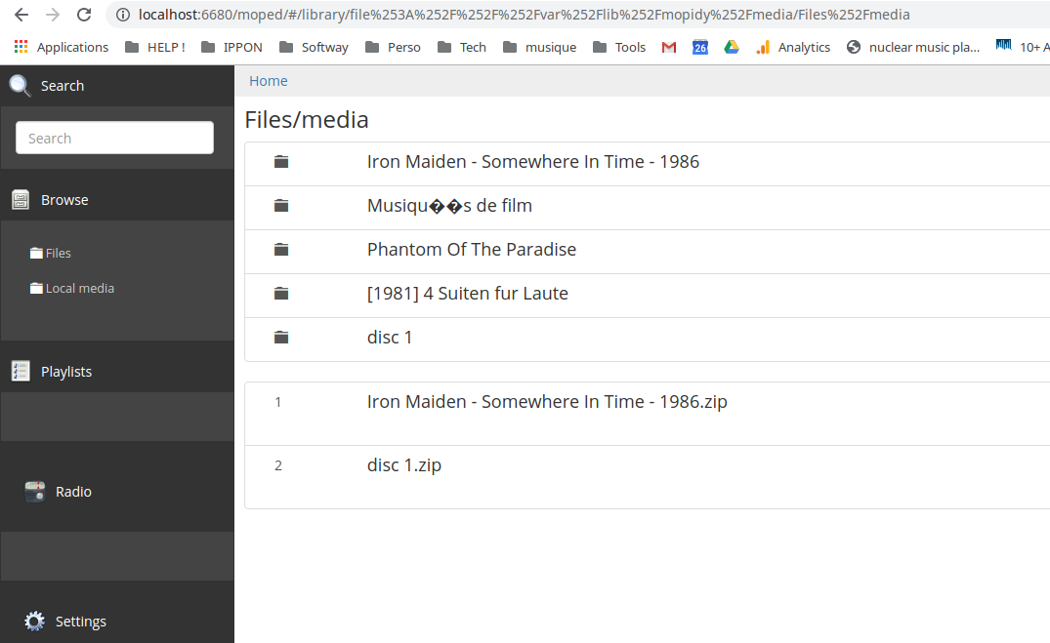

Fichiers son exemple.
http://www.music.helsinki.fi/tmt/opetus/uusmedia/esim/index-e.html

Configuration audio de mopidy
https://docs.mopidy.com/en/latest/audiosinks/

Utilise GStreamer
https://gstreamer.freedesktop.org/

-----
tester le son :

docker run --rm \
--user root --device /dev/snd \
wernight/mopidy \
gst-launch-1.0 audiotestsrc ! audioresample ! autoaudiosink

